Visual Thinking Strategies

The goal in all three strategies is to move kids along the continuum from simply seeing something to creating deeper meaning. When I work with students – no matter what strategy we’re using or what kind of evidence we’re looking at – I want them to jam into their brain these basic questions:

What do you see?
How can you organize what you see into patterns?
What do the patterns tell you?‘

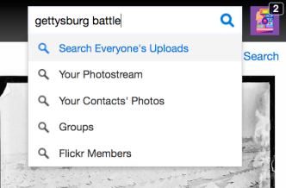
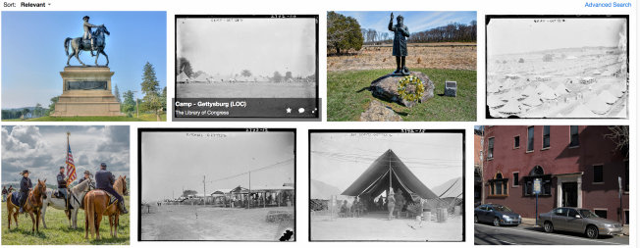
Three strategies to help your kids see better.

Strategy One
Five Card Flickr

In Five Card Flickr, give each student five random photos you’ve found and downloaded from Flickr. Use the search box in the top right-hand corner to search by specific tags, such as “gettysburg battle” or “ancient rome” to find photos to use.

flickr tags

Flickr tag search box
flickr example

Random photos using “gettysburg battle” tag

Ask students to do to the following:

- Write down a word that they connect with each image.
- Think of a song that comes to mind for one of images.
- Create a short phrase that describes what all the images have in common.
- Think of another image or video clip that comes to mind.
- Compare your answers with an elbow partner.

Follow this with a whole class discussion, asking kids to highlight what elements of the photo group prompted their responses.

A few extra ideas:

- Students can use this conversation as a writing prompt.
- Sometimes it’s fun to select seriously, completely random photos and force kids to find connections between the photos and a specific historical topic. They might have a picture of a worm, a house, a tree, a sword, and a big, red, hairy dog (See what I did there? Seriously, completely random photos). How might they be related? How would they connect back to the Battle of Gettysburg?
- Head over to the cool Five Card Flickr headquarters to get more ideas, story samples, and use their random photo picker to jump right in.
- 5cardflickr random
- Best for last? Head to the ESSDACK store and browse through the even cooler selection of PhotoSpark cards. PhotoSpark cards are large collections of individually laminated photos – ready for immediate use. With instructions!

Strategy Two
Reading News Media

Focus on using a graphic organizer to help scaffold questioning for students.The organizer asks kids to think about things such as:

- body language
- facial expression
- backgrounds
- non-verbal gestures
- camera angles

Strategy Three
What’s Going on in This Picture?

The New York Times wanted to know:

How do you make sense of what you see when you look at an image, especially if that image comes with no caption, headline, links or other clues about its origins? What can constructing meaning from an image teach you?

So they created something they call What’s Going on in This Picture? Their tool asks students to work together to analyze photos by focusing on news photos, visual literacy skills, and critical thinking. Each week a new photo is published without a caption. Students and teachers can take advantage of moderated online discussion after the photo is published. Later in the week, more information is provided – filling in gaps.

Get all of the photos here. And learn more about how other teachers are using the feature here.

